Ahsanullah University of Science and Technology

Department of Computer Science and Engineering

CSE 210: Digital Electronics and Pulse Techniques Sessional

**Experiment # 1 Section: B2 Time: 30 minutes**

**Name of the experiment: Study of DL and DTL gates.**

**All the circuits below have 100K resistors. You will have to change those. Please see the following instruction to change your 100K resistor values.**

|  |  |
| --- | --- |
| **160104104**  **160104122**  **160204009 absent**  **170204086**  **180204071 - A2**  **180204116**  **180204117**  **180204118**  **180204119**  **180204120**  **180204121**  **180204122**  **180204123**  **180204124**  **160104129 A2**  **180204092 B1**  **170104125 B1** | **Take the last two digits from your student ID. Put a dot(.) between them. Add to 100. For example –**  **if your id is 116, take the last two 16 make it 1.6**  **Then use 100+1.6 = 101.6 instead of 100 K in the circuits.** |
| **180204125**  **180204127**  **180204128**  **180204129**  **180204130**  **180204131**  **180204133**  **180204135**  **180204136**  **180204137**  **180204139**  **180204140**  **180204142**  **180204095 B1**  **170204062 B1**  **170204041 A2** | **Take the last two digits from your student ID. Put a dot(.) between them. Subtract from 100. For example –**  **if your id is 133, take 33 make it 3.3**  **Then use 100-3.3 = 96.7 instead of 100 K in the circuits.** |

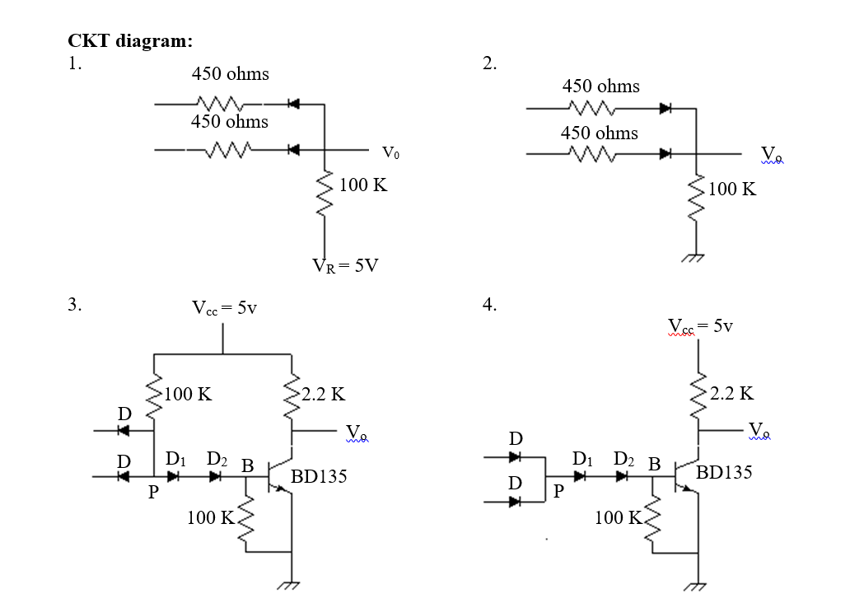

Procedure:

1. For ckt1 and ckt2 measure the output voltage Vo for all possible input combinations.
2. For ckt3 and ckt4 measure VD, VD1, VD2, VP, VCE, and Vo for all possible inputs.

Questions:

1. Analyze the ckt1 and ckt2 with the help of a truth table for both positive and negative logic. [ck1, ck2]
2. What happens if VR is more positive than V(1)? [ck1]
3. What happens if not all inputs have the same upper level? [ck1, ck2]
4. Why diode D2 is used? [ck3, ck4]
5. Can emitter and collector be interchanged? [ck3, ck4]
6. What is the significance of hFE(min)? [ck3, ck4]

Report:

1. Objective.
2. Circuit diagram.
3. Answer to the questions.
4. Experimental data.
5. Calculations.
6. Discuss the findings.